*And she’s got brains enough for two, which is the exact quantity the girl who marries you will need.*

*“I’m not absolutely certain of the facts, but I rather fancy it’s Shakespeare who says that it’s always just when a fellow is feeling particularly braced with things in general that Fate sneaks up behind him with the bit of lead piping.”*

*“A melancholy-looking man, he had the appearance of one who has searched for the leak in life’s gas-pipe with a lighted candle.”*

*“It isn’t often that Aunt Dahlia lets her angry passions rise, but when she does, strong men climb trees and pull them up after them.”*

*“Some minds are like soup in a poor restaurant – better left unstirred.”*

P.G. Wodehouse

**Introduction**

My R package **cricketr** had its genesis about 4 years ago, sometime around June 2015. There were some minor updates afterwards and the package performed analytics on cricketers (Test, ODI and T20) based on data from ESPN Cricinfo see [Re-introducing cricketr! : An R package to analyze performances of cricketers](https://gigadom.in/2016/05/14/re-introducing-cricketr-an-r-package-to-analyze-performances-of-cricketers/). Now, in the latest release of [cricketr](https://cran.r-project.org/web/packages/cricketr/index.html" \t "_blank), I have included 8 functions which can perform Team analytics. Team analysis can be done for Test, ODI and T20 teams.

This package uses the statistics info available in ESPN Cricinfo Statsguru. The current version of this package can handle all formats of the game including Test, ODI and Twenty20 cricket for players (batsmen & bowlers) and also teams (Test, ODI and T20)

You should be able to install the package directly from CRAN. Please be mindful of [ESPN Cricinfo Terms of Use](http://www.espncricinfo.com/ci/content/site/company/terms_use.html)

A total of 8 new functions which deal with team analytics has been included in the latest release.

There are 5 functions which are used internally 1) getTeamData b) getTeamNumber c) getMatchType d) getTeamDataHomeAway e) cleanTeamData

and the external functions which are  
a) teamWinLossStatusVsOpposition  
b) teamWinLossStatusAtGrounds  
c) plotTimelineofWinsLosses

All the above functions are common to Test, ODI and T20 teams

The data for a particular Team can be obtained with the getTeamDataHomeAway() function from the package. This will return a dataframe of the team’s win/loss status at home and away venues over a period of time. This can be saved as a CSV file. Once this is done, you can use this CSV file for all subsequent analysis

As before you can get the help for any of the cricketr functions as below

#help(teamWinLossStatusVsOpposition)

Compute the wins/losses/draw/tied etc for a Team in Test, ODI or T20 against opposition

Description

This function computes the won,lost,draw,tied or no result for a team against other teams in home/away or neutral venues and either returns a dataframe or plots it against opposition

Usage

teamWinLossStatusVsOpposition(file,teamName,opposition=c("all"),homeOrAway=c("all"),

matchType="Test",plot=FALSE)

Arguments

file

The CSV file for which the plot is required

teamName

The name of the team for which plot is required

opposition

Opposition is a vector namely c("all") or c("Australia", "India", "England")

homeOrAway

This parameter is a vector which is either c("all") or a vector of venues c("home","away","neutral")

matchType

Match type - Test, ODI or T20

plot

If plot=FALSE then a data frame is returned, If plot=TRUE then a plot is generated

Value

None

Note

Maintainer: Tinniam V Ganesh [tvganesh.85@gmail.com](mailto:tvganesh.85@gmail.com)

Author(s)

Tinniam V Ganesh

References

<http://www.espncricinfo.com/ci/content/stats/index.html>

<https://gigadom.in/>

See Also

teamWinLossStatusVsOpposition teamWinLossStatusAtGrounds plotTimelineofWinsLosses

Examples

## Not run:

#Get the team data for India for Tests

df <- getTeamDataHomeAway(teamName="India",file="indiaOD.csv",matchType="ODI")

teamWinLossStatusAtGrounds("india.csv",teamName="India",opposition=c("Australia","England","India"),

homeOrAway=c("home","away"),plot=TRUE)

## End(Not run)

This post has been published at RPubs and is available at [TeamAnalyticsWithCricketr](http://rpubs.com/tvganesh/503643" \t "_blank)

You can download PDF version of this post at [TeamAnalyticsWithCricketr](https://drive.google.com/file/d/1yRj_JP3P_qRYcTP3uGTmqGDXaLRqu0lZ/view?usp=sharing" \t "_blank)

**1. Get team data**

**1a. Test**

The teams in Test cricket are included below

1. Afghanistan 2.Bangladesh 3. England 4. World 5. India 6. Ireland 7. New Zealand 8. Pakistan 9. South Africa 10.Sri Lanka 11. West Indies 12.Zimbabwe

You can use this for the teamName paramater. This will return a dataframe and also save the file as a CSV , if save=TRUE

**Note**: – Since I have already got the data as CSV files I am not executing the lines below

# Get the data for the teams. Save as CSV

#indiaTest <-getTeamDataHomeAway(dir=".",teamView="bat",matchType="Test",file="indiaTest.csv",save=TRUE,teamName="India")

#australiaTest <- getTeamDataHomeAway(matchType="Test",file="australiaTest.csv",save=TRUE,teamName="Australia")

#pakistanTest <- getTeamDataHomeAway(matchType="Test",file="pakistanTest.csv",save=TRUE,teamName="Pakistan")

#newzealandTest <- getTeamDataHomeAway(matchType="Test",file="newzealandTest.csv",save=TRUE,teamName="New Zealand")

**1b. ODI**

The ODI teams in the world are below. The data for these teams can be got by names as shown below

1. Afghanistan 2. Africa XI 3. Asia XI 4.Australia 5.Bangladesh
2. Bermuda 7. England 8. ICC World X1 9. India 11.Ireland 12. New Zealand
3. Pakistan 14. South Africa 15. Sri Lanka 17. West Indies 18. Zimbabwe
4. Canada 21. East Africa 22. Hong Kong 23.Ireland 24. Kenya 25. Namibia
5. Nepal 27.Netherlands 28. Oman 29.Papua New Guinea 30. Scotland
6. United Arab Emirates 32. United States of America

#indiaODI <- getTeamDataHomeAway(matchType="ODI",file="indiaODI.csv",save=TRUE,teamName="India")

#englandODI <- getTeamDataHomeAway(matchType="ODI",file="englandODI.csv",save=TRUE,teamName="England")

#westindiesODI <- getTeamDataHomeAway(matchType="ODI",file="westindiesODI.csv",save=TRUE,teamName="West Indies")

#irelandODI <- getTeamDataHomeAway(matchType="ODI",file="irelandODI.csv",save=TRUE,teamName="Ireland")

**1c T20**

The T20 teams in the world are  
1.Afghanistan 2. Australia 3. Bahrain 4. Bangladesh 5. Belgium 6. Belize  
2.Bermuda 8.Botswana 9. Canada 11. Costa Rica 12. Germany 13. Ghana  
14.Guernsey 15. Hong Kong 16. ICC World X1 17.India 18. Ireland 19.Italy  
20.Jersey 21. Kenya 22.Kuwait 23.Maldives 24.Malta 25.Mexico 26.Namibia  
27.Nepal 28.Netherlands 29. New Zealand 30.Nigeria 31.Oman 32. Pakistan  
33.Panama 34.Papua New Guinea 35. Philippines 36.Qatar 37.Saudi Arabia  
38.Scotland 39.South Africa 40.Spain 41.Sri Lanka 42.Uganda  
43.United Arab Emirates United States of America 44.Vanuatu 45.West Indies

#southafricaT20 <- getTeamDataHomeAway(matchType="T20",file="southafricaT20.csv",save=TRUE,teamName="South Africa")

#srilankaT20 <- getTeamDataHomeAway(matchType="T20",file="srilankaT20.csv",save=TRUE,teamName="Sri Lanka")

#canadaT20 <- getTeamDataHomeAway(matchType="T20",file="canadaT20.csv",save=TRUE,teamName="Canada")

#afghanistanT20 <- getTeamDataHomeAway(matchType="T20",file="afghanistanT20.csv",save=TRUE,teamName="Afghanistan")

**2 Analysis of Test matches**

The functions below perform analysis of Test teams

**2a. Wins vs Loss against opposition**

This function performs analysis of Test teams against other teams at home/away or neutral venue. **Note**:- The opposition can be a vector of opposition teams. Similarly homeOrAway can also be a vector of home/away/neutral venues.

# Get the performance of Indian test team against all teams at all venues as a dataframe

df <- teamWinLossStatusVsOpposition("india.csv",teamName="India",opposition=c("all"),homeOrAway=c("all"),matchType="Test",plot=FALSE)

head(df)

## # A tibble: 6 x 3

## # Groups: Opposition [3]

## Opposition Result count

##

## 1 Afghanistan won 1

## 2 Australia draw 43

## 3 Australia lost 84

## 4 Australia tied 2

## 5 Australia won 52

## 6 Bangladesh draw 3

# Plot the performance of Indian Test team against all teams at all venues

teamWinLossStatusVsOpposition("indiaTest.csv",teamName="India",opposition=c("all"),homeOrAway=c("all"),matchType="Test",plot=TRUE)

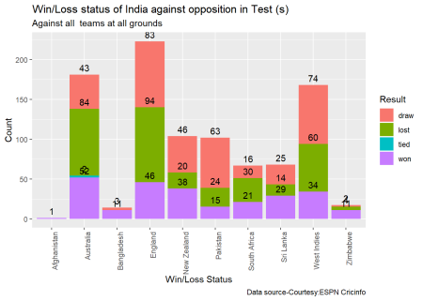

# Get the performance of Australia against India, England and New Zealand at all venues in Tests

df <-teamWinLossStatusVsOpposition("australiaTest.csv",teamName="Australia",opposition=c("India","England","New Zealand"),homeOrAway=c("all"),matchType="Test",plot=FALSE)

#Plot the performance of Australia against England, India and New Zealand only at home (Australia)

teamWinLossStatusVsOpposition("australiaTest.csv",teamName="Australia",opposition=c("India","England","New Zealand"),homeOrAway=c("home"),matchType="Test",plot=TRUE)

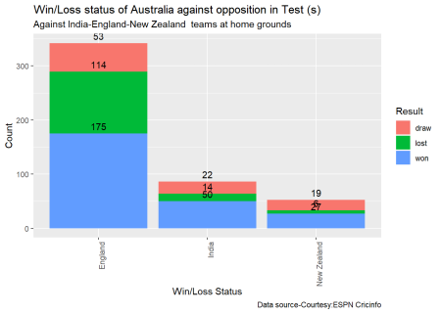

If you are passionate about cricket, and love analyzing cricket performances, then check out my racy book on cricket ‘Cricket analytics with cricketr and cricpy – Analytics harmony with R & Python’! This book discusses and shows how to use my R package ‘cricketr’ and my Python package ‘cricpy’ to analyze batsmen and bowlers in all formats of the game (Test, ODI and T20). The [paperback](https://www.amazon.com/dp/1095986953) is available on Amazon at $21.99 and  the [kindle](https://www.amazon.com/dp/B07R5HNQKG) version at $9.99/Rs 449/-. A must read for any cricket lover! Check it out!!

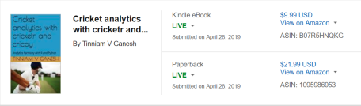

**2b Wins vs losses of Test teams against opposition at different venues**

# Get the performance of Pakistan against India, West Indies, South Africa at all venues in Tests and show performances at the venues

df <- teamWinLossStatusAtGrounds("pakistanTest.csv",teamName="Pakistan",opposition=c("India","West Indies","South Africa"),homeOrAway=c("all"),matchType="Test",plot=FALSE)

head(df)

## # A tibble: 6 x 3

## # Groups: Ground [5]

## Ground Result count

##

## 1 Abu Dhabi draw 2

## 2 Abu Dhabi won 4

## 3 Ahmedabad draw 2

## 4 Bahawalpur draw 1

## 5 Basseterre won 2

## 6 Bengaluru draw 5

# Plot the performance of New Zealand Test team against England, Sri Lanka and Bangladesh at all grounds playes

teamWinLossStatusAtGrounds("newzealandTest.csv",teamName="New Zealand",opposition=c("England","Sri Lanka","Bangladesh"),homeOrAway=c("all"),matchType="Test",plot=TRUE)

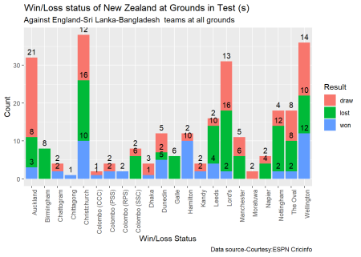

**2c. Plot the time line of wins vs losses of Test teams against opposition at different venues during an interval**

# Plot the time line of wins/losses of India against Australia, West Indies, South Africa in away/neutral venues

#from 2000-01-01 to 2017-01-01

plotTimelineofWinsLosses("indiaTest.csv",team="India",opposition=c("Australia","West Indies","South Africa"),

homeOrAway=c("away","neutral"), startDate="2000-01-01",endDate="2017-01-01")

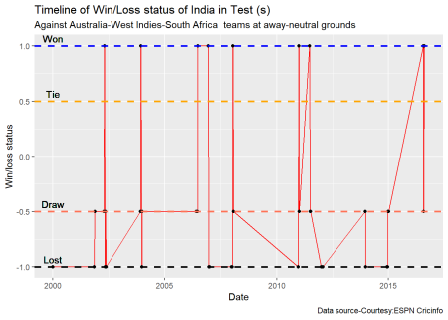

#Plot the time line of wins/losses of Indian Test team from 1970 onwards

plotTimelineofWinsLosses("indiaTest.csv",team="India",startDate="1970-01-01",endDate="2017-01-01")

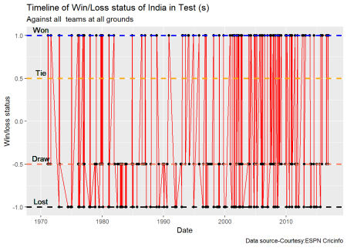

**3 ODI**

The functions below perform analysis of ODI teams listed above

**3a. Wins vs Loss against opposition ODI teams**

This function performs analysis of ODI teams against other teams at home/away or neutral venue. **Note**:- The opposition can be a vector of opposition teams. Similarly homeOrAway can also be a vector of home/away/neutral venues.

# Get the performance of West Indies in ODIs against all other ODI teams at all venues and retirn as a dataframe

df <- teamWinLossStatusVsOpposition("westindiesODI.csv",teamName="West Indies",opposition=c("all"),homeOrAway=c("all"),matchType="ODI",plot=FALSE)

head(df)

## # A tibble: 6 x 3

## # Groups: Opposition [2]

## Opposition Result count

##

## 1 Afghanistan lost 3

## 2 Afghanistan won 1

## 3 Australia lost 74

## 4 Australia n/r 3

## 5 Australia tied 3

## 6 Australia won 60

# Plot the performance of West Indies in ODIs against Sri Lanka, India at all venues

teamWinLossStatusVsOpposition("westindiesODI.csv",teamName="West Indies",opposition=c("Sri Lanka", "India"),homeOrAway=c("all"),matchType="ODI",plot=TRUE)

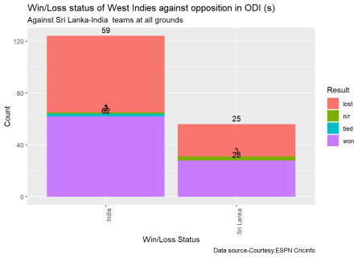

#Plot the performance of Ireland in ODIs against Zimbabwe, Kenya, bermuda, UAE, Oman and Scotland at all venues

teamWinLossStatusVsOpposition("irelandODI.csv",teamName="Ireland",opposition=c("Zimbabwe","Kenya","Bermuda","U.A.E.","Oman","Scotland"),homeOrAway=c("all"),matchType="ODI",plot=TRUE)

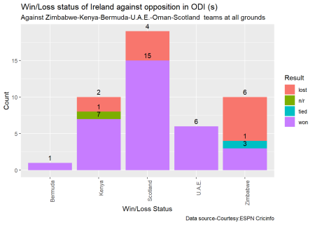

**3b Wins vs losses of ODI teams against opposition at different venues**

# Plot the performance of England ODI team against Bangladesh, West Indies and Australia at all venues

teamWinLossStatusAtGrounds("englandODI.csv",teamName="England",opposition=c("Bangladesh","West Indies","Australia"),homeOrAway=c("all"),matchType="ODI",plot=TRUE)

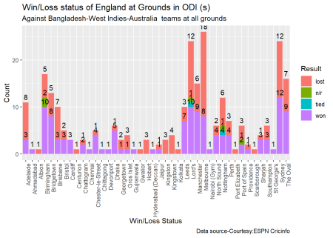

#Plot the performance of India against South Africa, West Indies and Australia at 'home' venues

teamWinLossStatusAtGrounds("indiaODI.csv",teamName="India",opposition=c("South Africa","West Indies","Australia"),homeOrAway=c("home"),matchType="ODI",plot=TRUE)

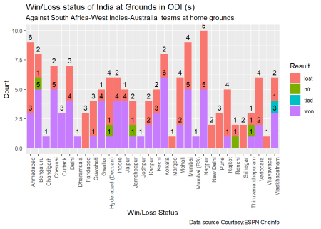

**3c. Plot the time line of wins vs losses of ODI teams against opposition at different venues during an interval**

#Plot the time line of wins/losses of Bangladesh ODI team between 2015 and 2019 against all other teams and at

# all venues

plotTimelineofWinsLosses("bangladeshOD.csv",team="Bangladesh",startDate="2015-01-01",endDate="2019-01-01",matchType="ODI")

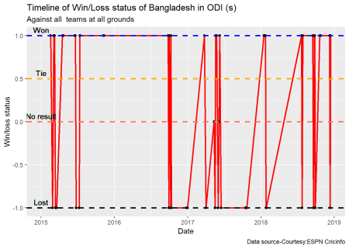

#Plot the time line of wins/losses of India ODI against Sri Lanka, Bangladesh from 2016 to 2019

plotTimelineofWinsLosses("indiaODI.csv",team="India",opposition=c("Sri Lanka","Bangladesh"),startDate="2016-01-01",endDate="2019-01-01",matchType="ODI")

**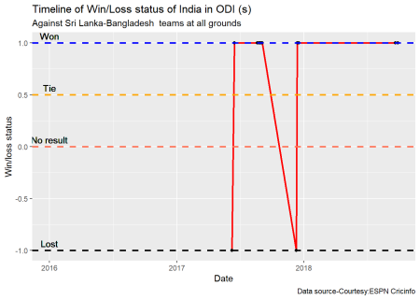**

**4 Twenty 20**

The functions below perform analysis of Twenty 20 teams listed above

**4a. Wins vs Loss against opposition ODI teams**

This function performs analysis of T20 teams against other T20 teams at home/away or neutral venue. **Note**:- The opposition can be a vector of opposition teams. Similarly homeOrAway can also be a vector of home/away/neutral venues.

# Get the performance of South Africa T20 team against England, India and Sri Lanka at home grounds at England

df <- teamWinLossStatusVsOpposition("southafricaT20.csv",teamName="South Africa",opposition=c("England","India","Sri Lanka"),homeOrAway=c("home"),matchType="T20",plot=FALSE)

#Plot the performance of South Africa T20 against England, India and Sri Lanka at all venues

teamWinLossStatusVsOpposition("southafricaT20.csv",teamName="South Africa",opposition=c("England","India","Sri Lanka"),homeOrAway=c("all"),matchType="T20",plot=TRUE)

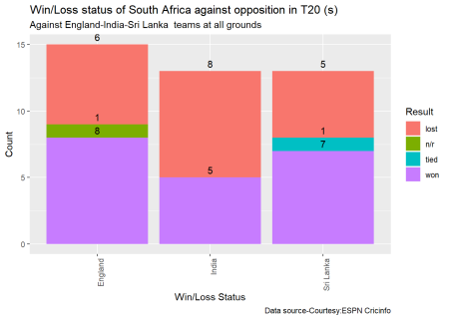

#Plot the performance of Afghanistan T20 teams against all oppositions

teamWinLossStatusVsOpposition("afghanistanT20.csv",teamName="Afghanistan",opposition=c("all"),homeOrAway=c("all"),matchType="T20",plot=TRUE)

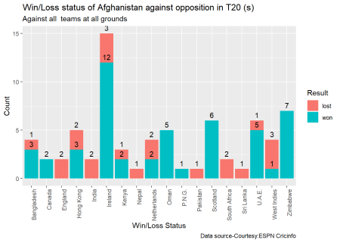

**4b Wins vs losses of T20 teams against opposition at different venues**

# Compute the performance of Canada against all opposition at all venues and show by grounds. Return as dataframe

df <-teamWinLossStatusAtGrounds("canadaT20.csv",teamName="Canada",opposition=c("all"),homeOrAway=c("all"),matchType="T20",plot=FALSE)

head(df)

## # A tibble: 6 x 3

## # Groups: Ground [4]

## Ground Result count

##

## 1 Abu Dhabi lost 1

## 2 Belfast lost 1

## 3 Belfast won 2

## 4 Colombo (SSC) lost 1

## 5 Colombo (SSC) won 1

## 6 Dubai (DSC) lost 5

# Plot the performance of Sri Lanka T20 team against India and Bangladesh in different venues at home/away and neutral

teamWinLossStatusAtGrounds("srilankaT20.csv",teamName="Sri Lanka",opposition=c("India", "Bangladesh"), homeOrAway=c("all"), matchType="T20", plot=TRUE)

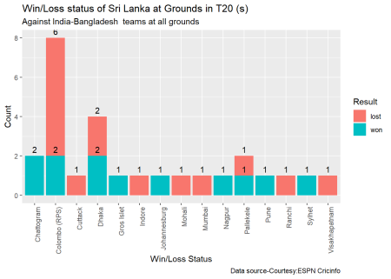

**4c. Plot the time line of wins vs losses of T20 teams against opposition at different venues during an interval**

#Plot the time line of Sri Lanka T20 team agaibst all opposition

plotTimelineofWinsLosses("srilankaT20.csv",team="Sri Lanka",opposition=c("Australia", "Pakistan"), startDate="2013-01-01", endDate="2019-01-01", matchType="T20")

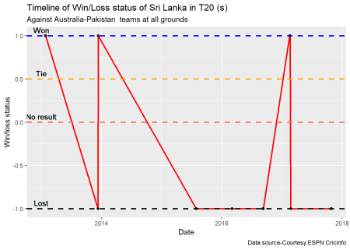

# Plot the time line of South Africa T20 between 2010 and 2015 against West Indies and Pakistan

plotTimelineofWinsLosses("southafricaT20.csv",team="South Africa",opposition=c("West Indies", "Pakistan"), startDate="2010-01-01", endDate="2015-01-01", matchType="T20")

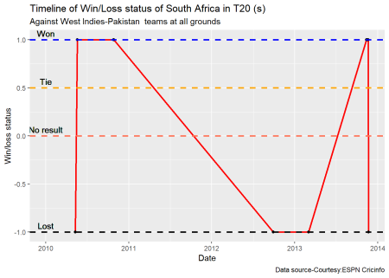

**Conclusion**

My R package cricketr now includes functions that analyze teams and players (batsmen & bowlers) in Test, ODI and T20 cricket.

Hope you have fun, with the package!